BASIC IPA FOR AMERICAN ENGLISH

Vowel Sounds
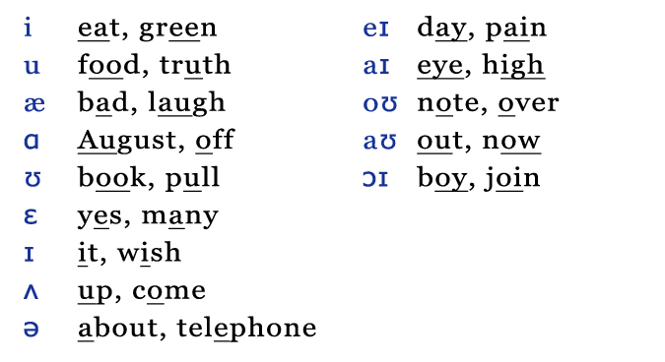

Consonant Sounds

Consonant Pairs
The mouth position for each pair of consonant sounds below is the same, but one sound is unvoiced while the other sound is voiced.
Unvoiced = only air comes out of your mouth
Voiced = your vocal cords produce a sound
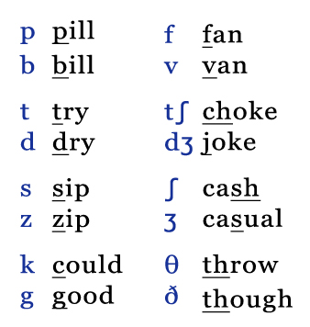

More Consonant Sounds (Unpaired)
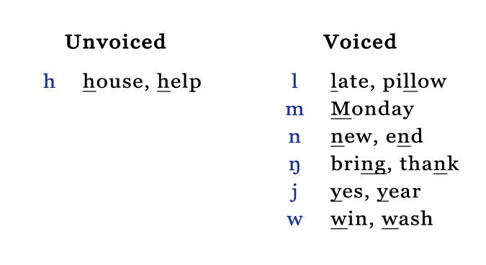
The American R Sounds
Here’s where things get confusing. This is the symbol for the American R consonant sound:
However, in most dictionaries, books and on websites, this is the symbol commonly used for the American R consonant sound
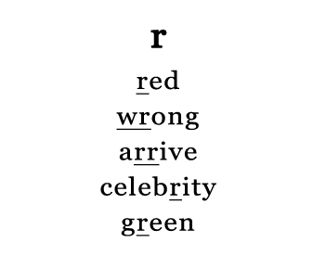
One of the main differences between British and American pronunciation is that Americans pronounce the R after a vowel, and the British don’t. The American vowel R sound (like at the -er end of brother) is written a few different ways.
When the American vowel R sound occurs in a one-syllable word or a stressed syllable, you will see it written these ways:
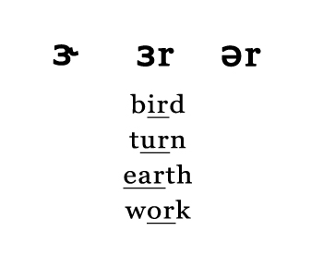
When the American vowel R sound occurs in an unstressed syllable, you will see it written these ways:
